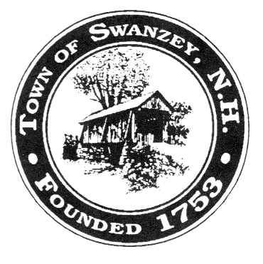
TOWN OF SWANZEY
NEW HAMPSHIRE
2025 VOTING GUIDE
OFFICIAL BALLOT VOTING

TUESDAY, MARCH 11, 2025
8:00 A.M. TO 7:00 P.M.

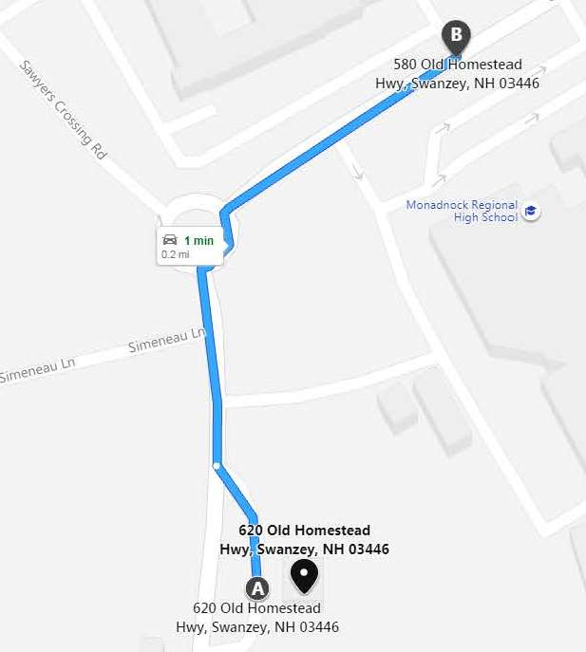
Location:
Monadnock Regional High School Gymnasium
580 Old Homestead Highway
Thank you MRSD School District for hosting our elections!

From Town Hall: school/voting site is 0.2 mile north on right.
From Lake Street: school/voting site is 2.4 miles south on the left.

It is not too late to register to vote!
You may register to vote at the polls on voting day.
Please remember to bring a valid photo ID.

Absentee Ballots are available through the Town Clerk’s office. You must appear in person by March 10th.
Please bring a valid photo ID.

Article 1 To choose by ballot town officers:

Selectman
For 3 Years (Vote for 1)
Robert L. DeRocher
Mark LaBelle
Michael R. York
_____________ (Write-in)

Trustee of Trust Fund
For 3 Years (Vote for 1)
Richard A. Scaramelli
_____________ (Write-in)

Zoning Board of Adjustment
For 2 Years (Vote for 1)
Jay Ward
_____________ (Write-in)

Zoning Board of Adjustment
For 3 Years (Vote for 1)
Adam Mulhearn
_____________ (Write-in)

Planning Board
For 3 Years (Vote for 2)
Scott Self
Richard Lane
___________ (Write-in)

Stratton Free Library Trustee
For 3 Years (Vote for 1)
David Hoitt
___________ (Write-in)

Mt. Caesar Union Library Trustee
For 1 Year (Vote for 1)
Scott Szymcik
___________ (Write-in)

Article 2 To vote by ballot on the following amendments to the Town of Swanzey Zoning Ordinance Recommended by the Planning Board:

Article 2 explanation: The explanation for the Planning Board’s proposed amendments to the Zoning Ordinance are shown here. The full text of the amendments in the Town Warrant, which is available on the Town’s website and at Town Hall. The Planning Board sought public feedback on the proposed zoning amendments at public hearings held on December 12, 2024 and January 9, 2025.

The objective of Amendment 1 is to revise our definitions for specific uses to align more effectively with the proposed changes. The updated definitions for Business Offices, Service Establishments, and Retail Establishments aim to clarify previously ambiguous language. The removal of the definition for "professional" is due to its redundancy. These changes mark the beginning of our efforts to simplify our zoning ordinance.

Amendment 2 would replace the existing “corporate offices” use with the new “business offices” use in the Rural/Agricultural district.

Amendment 3 would replace the existing “retail business establishment” and “personal service shop or service establishment” uses with the new “retail establishment” and “service establishment” uses in Village Business District I.

Amendment 4 would replace the existing “professional and business offices” and “retail sales, services” uses with the new “business offices” and “retail establishment” uses. This amendment would also add “service establishment” to the uses permitted in the Business District.

Amendment 5 would replace the existing “professional, business, or corporate offices”, “personal service shop or service establishment”, and “retail business establishment” uses with the new “business offices”, “service establishment”, and “retail establishment” uses in Village Business District II.

Amendment 6 would replace the existing “business and professional offices” and “retail sales, services” uses with the new “business offices” and “retail establishment” uses. This amendment would also add “service establishment” to the uses permitted in the Commercial/Industrial District.

Amendment 7 would replace the existing “corporate offices” use with the new “business offices” use in the Industrial Park District.

Article 2 explanation continued:
Amendment 8 would add Section VII, Article B.2 to the Wetlands Conservation District. The amendment defines wetlands more specifically to include marshes, swamps, bogs, vernal pools and wooded bottomlands, rivers, streams, and intermittent streams. It excludes waters covered by the Shoreland Protection District, such as lakes and 4th order streams, because state restrictions in that district are already more restrictive.

Amendment 9 would amend Section VII, Article D of the Wetlands Conservation District to offer more specific language on what is allowed in a wetland. Changes include prohibition of Forestry and Agriculture in wetlands, while requiring Best Management Practices be observed within 75 feet of wetlands. Fences, filling and dredging, and construction of new streets, roads, driveways and utilities in a wetland would be prohibited (thus requiring a variance). Maintenance and repair/replacement of existing lawful structures, utilities, roadways and driveways would be permitted.

Amendment 10 would add Section VII, Article F to the Wetlands Conservation District, exempting man-made, maintained and currently functioning ditches, stormwater swales, detention ponds, farm ponds and swales, and fire ponds and cisterns from the Wetlands Conservation District —provided they weren’t constructed as a mitigation project or created in what were previously jurisdictional wetlands.

Board of Selectmen’s comment: The Board of Selectmen has significant concerns with amendments 8, 9, and 10 due to potential unintended consequences. If approved, the Board feels they will negatively impact possible commercial and industrial development in many areas of Swanzey, most significantly the Safford Drive Industrial Park, where the taxpayers have invested millions of tax dollars to promote development.

Article 3 The zoning map of the Town of Swanzey dated 9/1/1947, as amended, is to be further amended as follows: lots fronting on Base Hill Road shall all be included in the Residence District, with the following exceptions:
1) Lots between New Run Brook and Rte. 10 which are currently in Commercial/Industrial District shall remain in that district (Tax Map 212, Lots 22 & 23 and Map 203 Lots 4, 30, & 29)
2) Tax Map 203, Lots 14, 20, 22, and 26 shall remain in the Business District
3) Tax Map 203, Lots 8, 13, and 20-1 shall be included in the Rural/Agricultural District
4) A portion of Tax Map 203, Lot 25, with an eastern boundary equal to the abutting lots on either side shall be included in the Resident District.

BY PETITION NOT RECOMMENDED BY THE PLANNING BOARD

Article 3 explanation: The explanation for the petitioned zoning amendment is shown here. You can find the full text of the petitioned zoning amendment in the Town Warrant (available on the Town’s website and at Town Hall). The Planning Board sought public feedback on the petitioned zoning amendment at a public hearing held on January 9, 2025. The Planning Board does not recommend this petitioned zoning amendment.

Article 3 would change the zoning on Base Hill Road from Business and Commercial/Industrial to primarily Residence. Lots between New Run Brook and Rte. 10 would remain Commercial/Industrial, and lots with currently operating businesses would remain zoned for business. Two lots owned by Yale Forest (Map 203 Lots 8 & 13) and one that is owned by All Purpose Storage (Map 203 Lot 20-1) would be rezoned to Rural/Agricultural. A portion of Map 203 Lot 25 that abuts Base Hill Road, owned by the Monadnock Humane Society, would be rezoned to Residence. The residents of Base Hill Road want to re-zone to be more in line with the rural/low-density zoning on Keene’s portion of the road. The Planning Board opposes this petitioned zoning amendment as it constitutes “spot zoning” and infringes upon the property rights of established businesses that have legally acquired property along Base Hill Road.

Article 4 Shall the Town vote to raise and appropriate the sum of Three Million and Five Hundred Thousand Dollars ($3,500,000) for the purpose of preparing plans and specifications, and constructing, equipping and furnishing a new Fire Station at Town owned property located at 321 Old Homestead Highway; One Hundred and Fifty Thousand Dollars ($150,000) to be raised by general taxation, Two Hundred Thousand Dollars ($200,000) from other available grants and/or aid, One Hundred and Fifty Thousand Dollars ($150,000) from the Undesignated Fund Balance, Five Hundred Thousand Dollars ($500,000) from the Fire Stations Capital Reserve Fund, and Two Million and Five Hundred Thousand Dollars ($2,500,000) of such sum to be raised through the issuance of bonds or notes under and in compliance with the Municipal Finance Act, RSA 33:1 et seq., as amended; to authorize the Selectmen to issue, negotiate, sell and deliver said bonds and notes and to determine the rate of interest thereon and the maturity and other terms thereof; to authorize the Selectmen to apply for, obtain and accept federal, state or other aid, if any, which may be available for said project and to comply with all laws applicable to said project; to authorize the Selectmen to take any other action or to pass any other vote relative thereto? (RECOMMENDED BY SELECTMEN – 3/5 Ballot Vote Required)

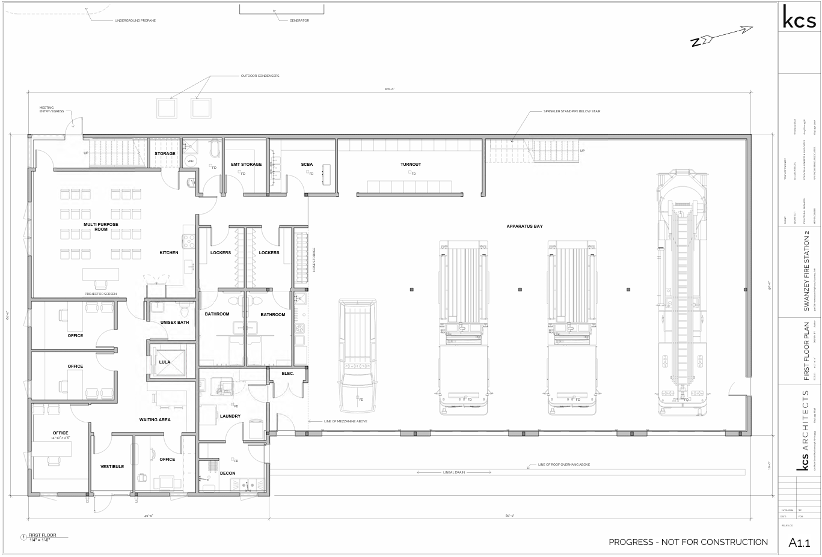
Article 4 explanation: This article would fund a new 6,400 square foot fire station at 321 Old Homestead Highway to replace Station #2 in basement of Town Hall for a total estimated cost of $3.5 million. This proposed fire station is 25% smaller and the total estimated cost is 33% lower than the proposal in 2024 and was developed by a citizen committee. The Fire Station Advisory Committee was tasked with developing a cost-effective proposal that met the project’s priorities: relocating Fire Station #2 out of the basement of Town Hall and providing a clean safe facility for the Fire Department.

Background
The Board of Selectmen has been trying to replace Fire Station #2 with a modern clean new fire station for over 10 years. The current Station #2 in the basement of the Town Hall cannot continue to be used because it is undersized, does not meet health and life safety code requirements, makes town hall employees sick, and has a number of other challenges. Modern fire trucks barely fit through the doors, under the ceiling, and between the columns in the truck bays. The firefighters’ lockers and gear are in the truck bays with the diesel exhaust from the trucks. Water leaks into the station through the building’s foundation. There is only one way in or out of the station, which is through the truck bays. The diesel fumes also go upstairs into the Town Hall where employees and members of the public are doing business.

About five years ago the Town bought 321 Old Homestead Highway, about a mile and a half north of the current Station #2 and in 2019 voters approved an article funding designing a fire station at 321 Old Homestead Highway. The design developed at that time after eight community meetings was about 12,500 square feet; it received over 50% support in 2020, 2021, and 2022, but not the 60% needed for approval. An 8,950 square feet station at a total cost of $5.28 million in 2024 received 54.7% support.

Design
The proposed station is 8,950 square feet and was developed by the Fire Station Advisory Committee with the design drawn by KCS Architects and the cost estimated by DEW Construction. The design priority was to get the cost as low as possible without compromising core program items (cancer prevention, call member spaces, etc.). This was accomplished by removing one of the double deep bays and shrinking the administrative areas. The sections of the building were also reorganized so additional bays can be added in the future if needed. The station has a dedicated training room, area for the emergency operations center, staff offices that are accessible to the public, four bays for trucks, and locker and decontamination areas for the department’s members. The proposed station does not include bedrooms or living quarters because Swanzey does not currently have full time / 24 hour staffing. If that space is needed in the future, there is the ability to add more usable space on the second floor.
Article 4 explanation (continued): If this article is approved, work will begin promptly to finalize architectural and engineering plans and construction is expected later in 2025 or early in 2026. If this article is not approved, the Town will continue to spend time and money studying this issue and/or developing different plans to replace Station #2.

Financial Overview:
- Total estimated cost - $3.5 million
- Bond for $2.5 million
- $200,000 congressionally directed spending grant
- $500,000 saved over several years in the Fire Stations CRF
- $150,000 2024 tax appropriation and $150,000 from fund balance
Not included in warrant article - InvestNH per unit affordable housing grant funds expected to be used for contingencies
Assuming a 25 year bond through the Municipal Bond Bank with an estimated 3.9% interest rate, the full projected annual payment once the bond has been issued (assumed to be in 2026) will be approximately $160,000 ($0.16 / $1,000 on the tax rate using 2024 assessed values).
Cost per year by assessed value: $100,000 - $16; $200,000 - $32; $300,000 - $48
Cost per day by assessed value: $100,000 - $0.04; $200,000 - $0.08; $300,000 - $0.12

The approximate tax rate impact of this article in 2025 is $0.15 / $1,000 based on 2024 assessed values. This information is provided for informational purposes only and is not a guarantee of actual bond costs.
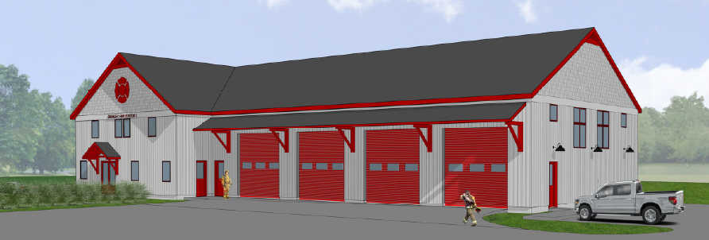
Article 5 Shall the Town vote to raise and appropriate the sum of Six Million and Four Hundred Thousand Dollars ($6,400,000) for the purpose of purchasing and making improvements to the West Swanzey Water Company including real property identified as Map 108 Lot 3 and Map 227 Lot 2, Six Million and Four Hundred Thousand Dollars ($6,400,000) of such sum to be raised through the issuance of bonds or notes under and in compliance with the Municipal Finance Act, RSA 33:1 et seq., as amended; to authorize the Selectmen to issue, negotiate, sell and deliver said bonds and notes and to determine the rate of interest thereon and the maturity and other terms thereof; to authorize the Selectmen to apply for, obtain and accept federal, state or other aid, if any, which may be available for said project and to comply with all laws applicable to said project; to authorize the Selectmen to take any other action or to pass any other vote relative thereto? Additionally, to authorize the Selectmen to participate in the Drinking Water State Revolving Loan Fund established for this purpose, which is a low interest loan with 40% principal forgiveness. Without impairing the general obligation nature of the bond or note issued for the project, payments on such bonds and/or notes are expected to be accounted for in a water enterprise fund paid by the water system users through user fees. This appropriation is conditional upon approval of Article 12; if Article 12 fails, this article will be null and void. (RECOMMENDED BY SELECTMEN - 3/5 Ballot Vote Required)

Article 5 explanation: The Town has been considering acquiring the West Swanzey Water Company for many years, however has not moved forward with a proposal due to incomplete information regarding the status of the system. The West Swanzey Water Company is a private water utility that serves approximately 218 service connections in the area of Rt. 10 between North and South Winchester Streets. In 2023 the Town received a grant from the State to study the status and finances of the system to assess its condition. That study identified an acquisition and improvement plan with a total budget of $6.4 million, which would purchase the system and make improvements to bring it to municipal standards. The main improvements are a new pump house and storage tank, which is critical for firefighting and fire suppression. This study put the Town in a position to begin seeking grants and other funding sources, which led the NH Drinking Water Trust Fund to award a low interest loan of $6.4 million, with 40% of the principal (or $2,560,000) forgivable. This means the local cost is expected to be $3,840,000 paid by the users of the water system. The current owners of the West Swanzey Water Company no longer want to own and the operate the system and would like to sell it to the Town.

If this Article and Article 12 are approved, the Town will need to ratify this decision at another Town Meeting, likely a special Town Meeting later in 2025. After the decision is ratified, the Town would likely take ownership of the system later in 2025 and begin operating it. Improvements will begin after they are fully designed and bid. The improved system would provide more reliability for the users and increase capacity for firefighting and commercial development; it will likely also increase user fees. The water system will be operated as an enterprise fund with the expenses and revenues accounted for separately from the Town’s general operations and will be paid by users of the system. If this Article and Article 12 are rejected, this subject may not be reconsidered for two years. If it is reconsidered, it is unlikely 40% principal forgiveness will again be available. If the WEST Swanzey Water Company were to fail it is unclear what would happen.

This article is not expected to have a direct impact on the 2025 tax rate.

Article 6 Shall the Town vote to raise and appropriate the sum of One Hundred Thousand dollars ($100,000) for the purpose of funding a comprehensive stormwater planning capital improvement plan, such sum to be raised through the issuance of bonds or notes not to exceed $100,000 under and in compliance with the Municipal Finance Act, RSA 33:1 et seq., as amended; to authorize the Selectmen to issue, negotiate, sell and deliver said bonds and notes and to determine the rate of interest thereon and the maturity and other terms thereof; to authorize the Selectmen to apply for, obtain and accept federal, state or other aid, if any, which may be available for said project and to comply with all laws applicable to said project; to authorize the Selectmen to take any other action or to pass any other vote relative thereto? Additionally, to authorize the Selectmen to participate in the Clean Water State Revolving Loan Fund established for this purpose. This project is expected to receive 100% principal forgiveness. (RECOMMENDED BY SELECTMEN - 3/5 Ballot Vote Required)

Article 6 explanation: The Town has been awarded a $100,000 forgivable loan through the State to fund a stormwater capital improvement plan. This plan will identify priority stormwater projects and will help put the Town in a position for grants to help fund them. Thanks to 100% principal forgiveness, this article is expected to have a minimal cost to the Town. Because from the State’s perspective the forgivable loan still requires borrowing authority from the Town, this article is required. If this article is approved, a design consultant will be selected and work is expected to start later this year. If this article is rejected, the Town does not expect to develop a stormwater capital improvement plan.

This article is not expected to have a direct impact on the 2025 tax rate.

Article 7 Shall the Town vote to raise and appropriate as an operating budget, not including appropriations by special warrant articles and other appropriations voted separately, the amounts set forth on the budget posted with the warrant or as amended by vote of the First Session, for the purposes set forth therein, totaling $8,370,000? Should this article be defeated, the default budget shall be $7,935,699, which is the same as last year, with certain adjustments required by previous action of the Town or by law; or the governing body may hold one special meeting, in accordance with RSA 40:13, X and XVI, to take up the issue of a revised operating budget only. (RECOMMENDED BY SELECTMEN)

Article 7 explanation: The Board of Selectmen’s 2025 Operating Budget is $8,370,000, which is an increase of 5.1% from last year. Since Swanzey is a SB2 community, the voters are given two options when voting on this article, the first is for the recommended budget and the second is the default budget, which is $7,935,699 and would go into effect if this article were to fail. Due to rising costs that cannot be incorporated in the default budget for items such as insurance rate increases, adoption of the default budget would likely result in reductions in services and staffing levels in addition to not funding the increases outlined as follows. After the Budget Hearing the Selectmen reviewed the budget and identified decreases based on accounting for vacant positions to lower this article over $300,000. The major increases in the recommended budget are: employee related costs, additional payroll in the Department of Public Works, increased need for general assistance and higher welfare costs, and additional payroll in the Recreation Department. The major decrease is in the insurance budget based on the change in budgeting for vacant positions. Reducing the budget further or voting for the default budget will negatively impact the Town’s ability to provide core services. The major decreases in the recommended budget are for fewer elections in 2025 and less money in the insurance budget based on the change in accounting for vacant positions.

Default Budget
By law, the default budget is the same budget as last year with increases for contracted and legal obligations and decreases for one-time expenses and reductions in debt service. The 2025 default budget is $7,935,699, $25,801 lower than the 2024 budget and $434,301 lower than the 2025 recommended budget. The decrease in the default budget is based on fewer elections and paying down debt.

Article 7 explanation continued:

Operating Budget Summary
Overall 2025 recommended budget increase from 2024 of about $408,000 (+ 5.1%)
The recommended budget is $434,000 higher than the default budget
Net estimated non-property tax revenues are approximately $72,000 higher than 2024
Net amount to be raised by taxes for the budget is $4,250,492, an increase of $336,000 (8.6%)
The approximate tax rate impact of the recommended budget is $4.23 / $1,000 based on 2024 assessed values.

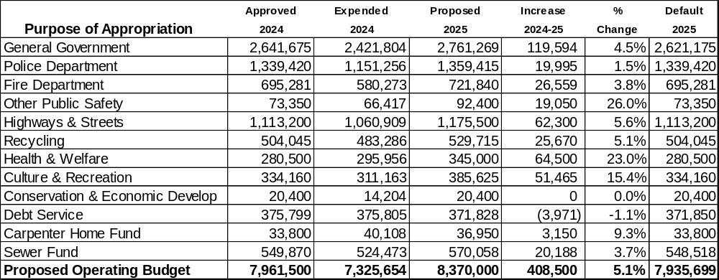

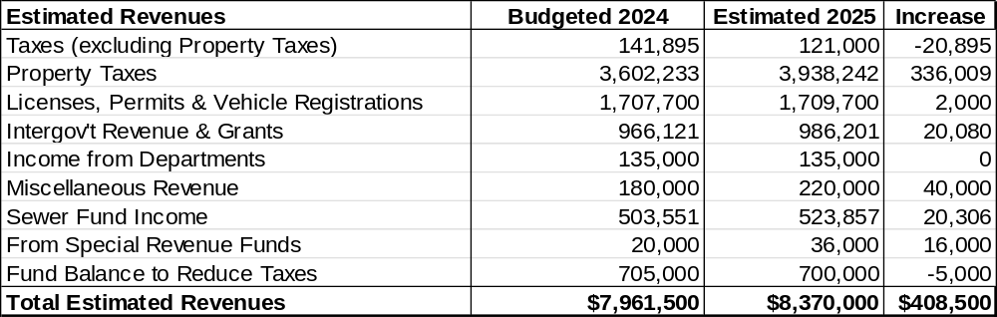

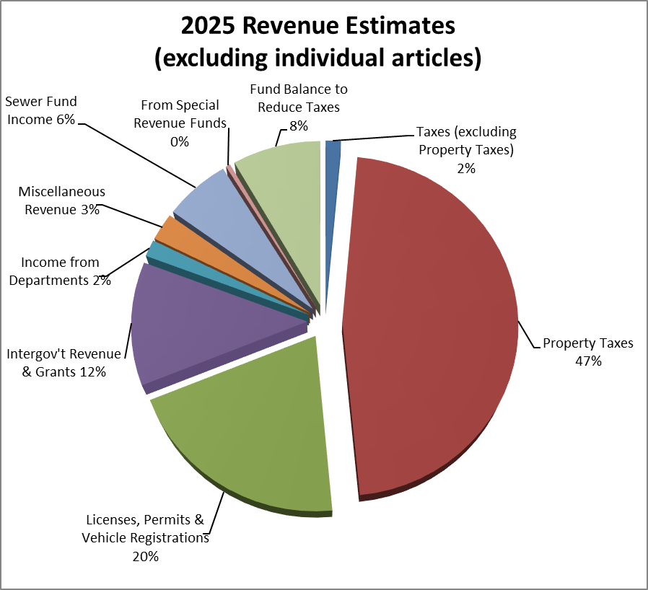

Article 8 Shall the Town vote to raise and appropriate the sum of Four Hundred and Seventy-Seven Thousand and Five Hundred ($477,500) by general taxation to be placed in the following expendable trust and capital reserve accounts of the Town:
Expendable Trust Funds | Amount | Capital Reserve Funds | Amount
Revaluation & Updates | $30,000 | Fire Stations | $10,000
Emergency Communications | $10,000 | Fire Trucks | $30,000
Fire Ponds | $20,000 | Police Cruisers | $75,000
Fire Dept. Tools & Equip. | $10,000 | Recreation Facility Improvements | $25,000
Mt. Caesar Library | $50,000 | Recycling Center Improvements | $75,000
Police Facilities Maintenance | $7,500 | Golden Rod Grange Hall | $75,000
Police IMS | $5,000
Stratton Free Library | $15,000
Whitcomb Hall | $20,000
Town Hall IMS | $20,000
(RECOMMENDED BY SELECTMEN)
Article 8 explanation: An article similar to this one and Article 9 appear on the warrant each year to save money in the Town’s various capital reserve and expendable trust funds. These funds are critical to the Town’s operations and are used throughout the year to make major capital purchases of vehicles and equipment, to make repairs and improvements to the Town’s buildings and infrastructure, and for a number of other purposes. Funds are held and invested by the Trustees of Trust Funds and expenditures are restricted to the purposes approved by voters when each fund was created. All funds are reviewed by the Capital Improvements Plan Committee, which recommends annual funding levels to the Board of Selectmen. The major funds having their contributions changed compared to last year are: Mt. Caesar Union Library - $50,000, Golden Road Grange Hall - $36,000, Recycling Center + $25,000, and Whitcomb Hall + $20,000. This article is critical to the implementation of the Town’s six-year capital improvement plan and if it were to fail it would have a significant impact on the Town’s ability to deliver key services and complete projects.

The approximate tax rate impact of this article is $0.48 / $1,000 based on 2024 assessed values.
Article 9 Shall the Town vote to raise and appropriate the sum of Six Hundred and Eighty-Five Thousand Dollars ($685,000) by general taxation to be placed in the following expendable trust and capital reserve accounts of the Town?
Expendable Trust Funds | Amount | Capital Reserve Funds | Amount
DPW Facilities | $15,000 | Highway & Cemetery Equipment | $200,000
Road Rehab & Reconstruction | $400,000 | Sidewalk | $35,000
Rail Trails | $10,000 | Town Bridges | $25,000
(RECOMMENDED BY SELECTMEN)
Article 9 explanation: An article similar to this one and Article 8 appear on the warrant each year to save money in the Town’s various capital reserve and expendable trust funds. See the Article 8 explanation for more information regarding capital reserve and expendable trust funds.

The major funds having their contribution increased compared to last year is Covered Bridges + $25,000 and Sidewalks + $10,000.

This article is critical to the implementation of the Town’s six-year capital improvement plan and if it were to fail it would have a significant impact on the Town’s ability to deliver key services.

The approximate tax rate impact of this article is $0.68 / $1,000 based on 2024 assessed values.

Article 10 Shall the Town vote to raise and appropriate the sum of Three Hundred Thousand Dollars ($300,000) to be placed in the Fire Stations Capital Reserve Fund with such sum to be raised One Hundred and Fifty Thousand Dollars ($150,000) by taxation and One Hundred and Fifty Thousand Dollars ($150,000) from the undesignated fund balance? If Article 4 passes this article shall be null and void.
(RECOMMENDED BY SELECTMEN)

Article 10 explanation: An article like this one has appeared on the warrant the last few years. This article is contingent on Article 4 so if Article 4 fails the Town can continue to save towards fire station improvements or a new station. If Article 4 passes, regardless of the vote on this article it will not be approved. If Article 3 fails and this article passes, $300,000 will be added to the Fire Stations Capital Reserve Fund. This money could then be used to maintain or repair the Town’s three current fire stations or to save towards a new fire station, helping to reduce the amount of money that would need to be borrowed. $150,000 of this proposed article will be funded by general taxation and $150,000 will be from the undesignated fund balance.

The approximate tax rate impact of this article is $0.15 / $1,000 based on 2024 assessed values.

Article 11 Shall the Town vote to create the West Swanzey Tax Increment Financing (TIF) District as follows?
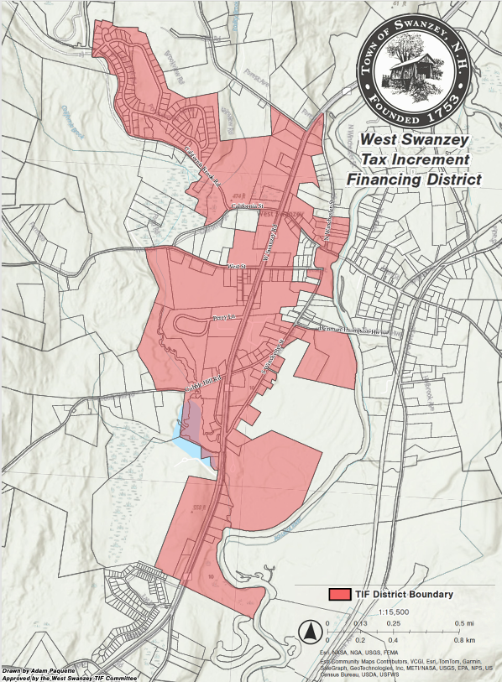
- Establish the West Swanzey Tax Increment Financing (TIF) District in accordance with RSA 162-K. The proposed district includes 132 properties near NH Route 10 as represented in the map found in Section 5 of the Development Program and Financing Plan adopted by the Board of Selectmen at the public hearing on January 15, 2025.
- Adopt the provisions of the West Swanzey TIF District Development Program and Financing Plan adopted by the Board of Selectmen at the public hearing on January 15, 2025 in accordance with RSA 162-K:6 and RSA 162-K:9. Copies of the West Swanzey TIF District Map, Development Program, and Financing Plan are available at the Town Hall and online at www.swanzeynh.gov.
- Authorize the Board of Selectmen to appoint the District Administrator in accordance with RSA 162-K:13 and to create a five-member Advisory Board in accordance with RSA 162-K:14, with the Advisory Board membership to be determined by the Board of Selectmen.
(RECOMMENDED BY SELECTMEN)

Article 11 explanation: This article would create the West Swanzey Tax Increment Financing (TIF) District, which would use future tax payments on assessed value increases in the district to fund infrastructure improvements. This district was recommended by an advisory committee and is currently expected to fund water and sewer system improvements or line extensions in West Swanzey without raising taxes or user fees. There is no added cost to properties within the district. Swanzey’s first TIF District built Safford Drive and will retire in the next few years.
This article has no direct tax impact.
Article 12 Shall the Town vote, pursuant to RSA 38:4, to authorize the Selectmen to enter into an agreement to purchase the assets of the West Swanzey Water Company to provide service to the customers of that company. If this article is approved, the Selectmen will negotiate an agreement which will be subject to approval at a future annual or special town meeting; the purchase cannot proceed without approval at a future meeting. If this article is defeated, the question may not be submitted again for two years.
(RECOMMENDED BY SELECTMEN 2/3 Ballot Vote Required)

Article 12 explanation: This article allows the Selectmen to begin the process to purchase the West Swanzey Water Company through the process outlined in RSA 38:4. If this article is approved, the purchase agreement will need to be finalized and approved by a future Town Meeting, likely later in 2025. If this article is rejected, it cannot be reconsidered for two years.
This article has no direct tax impact.

Article 13 Shall the Town vote to raise and appropriate the sum of One Hundred Thousand Dollars ($100,000) to be placed in the Ambulance Expendable Trust Fund with such sum to be raised from the undesignated fund balance? (RECOMMENDED BY SELECTMEN)

Article 13 explanation: This article would save $100,000 in the Ambulance Expendable Trust Fund created in 2024. The Town’s current contract for ambulance services with Cheshire County EMS runs until June 30, 2026. After the current contract, the Town expects significantly higher costs and this article saves to help soften that cost increase. Because it is funded by the undesignated fund balance it has no direct tax impact.

Article 14 Shall the Town vote to re-adopt, pursuant to RSA 72:81, a new construction property tax exemption for commercial and industrial uses (as defined in RSA 72:80). For the purpose of this exemption, in order to satisfy the public benefit requirement a minimum of one of the following must be provided: enhance economic growth and increase the Town’s tax base; creation of needed services or facilities not currently available in the Town; redevelop and revitalize commercial or industrial area; prevent or eliminate blight; or, retain local jobs, increase local job base, and/or provide diversity in the job base. If approved, this exemption shall continue to be in effect in the tax year beginning April 1, 2025 and shall remain in effect for a maximum of 5 tax years. (RECOMMENDED BY SELECTMEN)

Article 14 explanation: This article would re-adopt the new commercial and industrial tax exemption adopted in 2020. This exemption allows the Selectmen to grant temporary exemptions on commercial and industrial improvements when there is a public benefit, such as: increasing the tax base, creating jobs, or redeveloping blighted areas. To date, the Town has approved two such exemptions.

Article 15 Are you in favor of increasing the board of selectmen to 5 members? (By Petition)

Article 15 explanation: This article was submitted by petition and would increase the Board of Selectmen from three to five members. If approved, this would go into effect in 2026.

Article 16 We, the people of Swanzey, petition to the town to add a second polling location for all voting, local and federal, at 17 Main St, Whitcomb Hall; and to raise and appropriate $15000.00 for the additional costs of vote counting machines, programming, and staffing, with the addition to be completed by the next even year election. (By Petition) (NOT RECOMMENDED BY SELECTMEN)

Article 16 explanation: This article was submitted by petition and would create a second polling place for all elections beginning in 2026. The Selectmen would create the boundaries to determine which polling place voters throughout town would have to use. Voters would not be able to choose the polling place they wanted. The Selectmen feel that this would create logistical challenges that would make voting and the election process more difficult without a clear benefit. The article also appropriates $15,000 towards costs to set up the polling place, which the Selectmen and election officials believe is under the actual costs.

The approximate tax rate impact of this article is $0.01 / $1,000 based on 2024 assessed values.

2025 Town Warrant Summary

Articles 4, 7, 8, 9, 10, and 16 are the articles that have a direct impact on the 2025 Town Tax Rate. Article 4 will also impact the tax rate in future years when the bonds are issued. If the Selectmen recommended articles pass the net amount to be raised by taxes would be $5,562,000 for a projected Town tax rate of $5.54. For a property valued at $100,000, the estimated Town portion of 2025 taxes is $554 (7.3% higher than the $516 in 2024).

Projected annual Town tax payment increase in 2025 by assessed value:
$100,000 property - $38; $200,000 property - $76; $300,000 property - $114
For reference in 2024 the Town portion made up roughly 27% of the overall tax rate, meaning – for example – if your total property tax bill was $1,000, the Town’s portion was $270.

2020 Revenues -

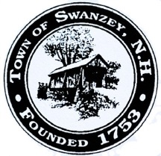
Town of Swanzey
620 Old Homestead Highway PO Box 10009
Swanzey, NH 03446-0009
(603) 352-7411
www.swanzeynh.gov

PRSRT. STD. PAID
Swanzey, NH Permit #11 ECRWSS

BRING IT TO THE POLLS!
Town Ballot

Article 4 Y N
Article 5 Y N
Article 6 Y N
Article 7 Y N
Article 8 Y N
Article 9 Y N
Article 10 Y N
Article 11 Y N
Article 12 Y N
Article 13 Y N
Article 14 Y N
Article 15 Y N
Article 16 Y N

Town Ballot

Zoning Amendments
Amendment 1 Y N
Amendment 2 Y N
Amendment 3 Y N
Amendment 4 Y N
Amendment 5 Y N
Amendment 6 Y N
Amendment 7 Y N
Amendment 8 Y N
Amendment 9 Y N
Amendment 10 Y N
Article 3 Y N

Postal Patron
Swanzey, NH 03446

Town & School District Official Ballot Voting Tuesday, March 11, 2025

8:00 a.m. to 7:00 p.m.
Polls are located at the
Monadnock Regional High School Gym,
580 Old Homestead Hwy, Swanzey

This voting guide previews Town offices to be filled by election and the official ballot questions that resulted from our deliberative session on February 4th. The guide explains each ballot question in everyday terms.

The Town’s Annual Report contains additional information about matters to be considered by official ballot as well as finances and activities of the Town during the past year. The Annual Report is available at Town Hall and may be viewed at www.swanzeynh.gov under the Community tab.
The Selectmen, board and committee members, the Town Administrator and other department leaders welcome your questions and feedback. Your vote does count! Participate in making the decisions that will shape the future of our town and come to the polls on March 11th!
Sly Karasinski
Bill Hutwelker
James Tempesta
Swanzey Board of Selectmen
Town Hall hours on Election Day
On Election Day (March 11th), the Town Clerk’s Office will be closed but the other offices in Town Hall will hold regular business hours from 8:00 a.m. to 5:00 p.m.

Make a difference
Your town needs you! The Board of Selectmen often seeks nominations for positions on Town boards, committees and commissions. Consult the Annual Report to see which groups most interest you, contact Town Hall staff or volunteers with any questions, and find nomination forms and additional information at www.swanzeynh.gov.

Town Hall Hours
Town Clerk: Monday, Tuesday and Thursday 8 – 4:30, Wednesday 9 – 7, and Friday 7:30 – 12:00
All other offices: Monday – Thursday 8 – 5 & Friday 8 – 12. Did you know you can do many transactions online 24/7 from the comfort of your own home? If you want to see if you can do your business online, check our website or contact the Tax Collector or Town Clerk.

